Chapter 9 Energy, work and power

Chapter test Total marks 45

Name: ______________________________ Class: ____________ Date: _______________

Section A (2 marks per question)

Use *g* = 9.80 m s–2 throughout.

Question 1

A girl lifts a 4.7 kg bowling ball from the floor to a shelf 1.8 m high. What is the work done by the girl?

A 43 J

B 83 J

C 8.3 J

D 14.0 J

Question 2

A 60 kg jogger uses 2200 J of energy when he runs up a 30 m–high hill in 85.0 s. Which of the following is his power output during the run?

A 21.2 W

B 25.9 W

C 1.55 kW

D 6.23 kW

Question 3

A 45 kg gymnast is at the top of a vertical jump, 7.2 m above the trampoline mat. Which one of the following statements is correct?

A She has maximal gravitational potential energy and minimal kinetic energy.

B She has maximal gravitational potential energy and maximal kinetic energy.

C She has minimal gravitational potential energy and maximal kinetic energy.

D She has minimal gravitational potential energy and minimal kinetic energy.

*The following information applies to questions 4–6.*

A small boy drags his broken bicycle across the lawn at a constant speed of 0.20 m s–1. To overcome friction, the boy exerts a horizontal force of 9.0 N. The lawn is 8.0 m wide.

Question 4

How much time will it take for the boy to cross the lawn?

A 1.6 s

B 4.0 s

C 16 s

D 40 s

Question 5

What is the work done by the boy in pulling his bike across the lawn?

A 1.8 J

B 14.4 J

C 72 J

D 80 J

Question 6

What is the power output of the boy?

A 1.8 W

B 14.4 W

C 72 W

D 80 W

Section B

Question 7

During an AFL game, a player kicks the ball of mass 500 g from 1.00 m above the ground so that it travels vertically upwards with a speed of 25 m s–1.

a What is the kinetic energy of the ball as it is first kicked? (1 mark)

b Determine the maximum height to which the ball travels. (3 marks)

Question 8

A bungee jumper of mass 70.0 kg jumps from a height of 110 m. Before reaching the bottom of the jump, at a height of 30.0 m, her cord starts to stretch so that she is travelling at a speed of 25.0 m s–1. How much of her energy was converted into heat and the stretching of the cord? Express this as a percentage. (4 marks)

Question 9

Define an elastic collision. (1 mark)

Question 10

A spring has a force–displacement graph as shown below.

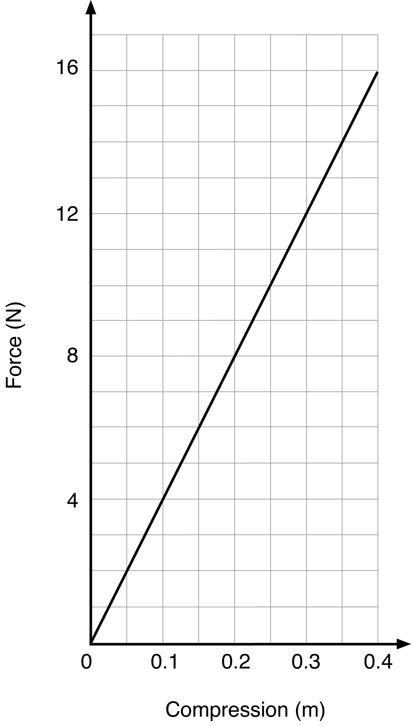

a Identify the spring as elastic, inelastic or partially elastic, giving a reason to support your answer. (2 marks)

b Use the graph to determine how much work is done in compressing the spring from:

i 0.0 to 0.1 m (3 marks)

ii 0.1 to 0.4 m. (3 marks)

Question 11

A 1250 kg car travelling at 70 km h–1 slides off the road and into a tree, coming to a complete halt. How much work has been done on the car in bringing it to a halt? (3 marks)

Question 12

The diagram below shows a new section of roller-coaster track that is being tested. The mass of an empty carriage is 350 kg. The carriage is momentarily at rest at point R before it rolls towards point S. Ignore any effects due to friction when answering the following questions.

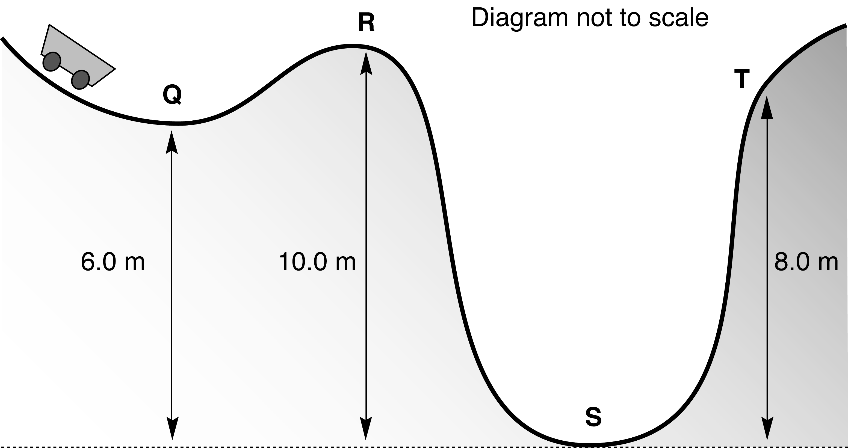

a What is the gravitational potential energy of the carriage at point R? (1 mark)

b What is the kinetic energy of the carriage at point R? (1 mark)

c What is the kinetic energy of the carriage at point S? (1 mark)

d What speed is the carriage travelling when it passes through point S? (2 marks)

e The carriage passes through point S, heading towards point T. Calculate the speed of the carriage as it passes through point T. (3 marks)

f During another trial run, the carriage travels through point Q with enough speed so that it can just reach point R. What is the speed of the carriage at point Q during this trial? (3 marks)

Question 13

A 0.45 kg ball is thrown horizontally west at a wall with a speed of 17 m s–1. It rebounds horizontally at 14 m s–1 east.

a Was the collision elastic or inelastic? Give a reason to support your answer. (1 mark)

b Where has the ‘lost’ kinetic energy gone? (1 mark)